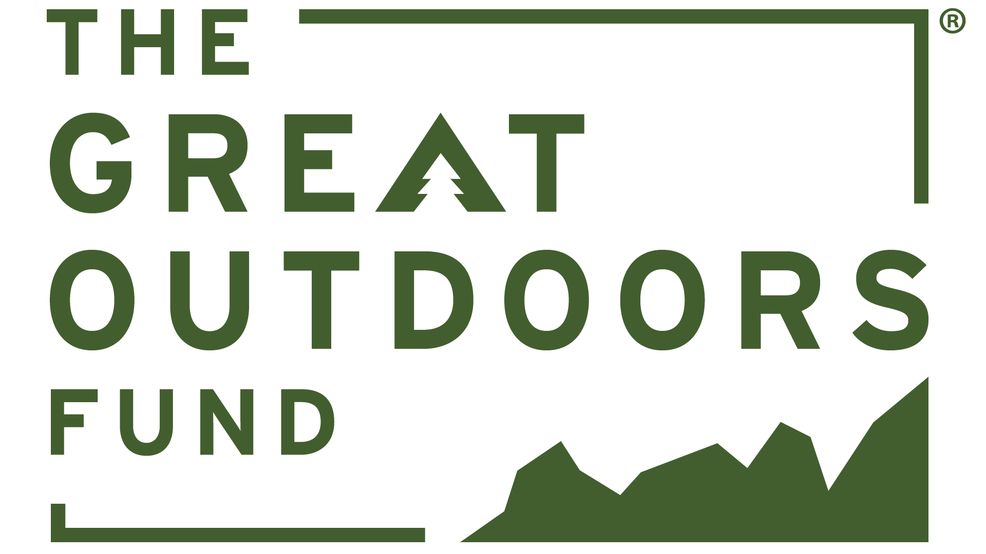
Project Entry Template for The Fund dB (Project Database)

NOTE: Please fill out this form completely before entering all information into the database. You will not be able to save a DRAFT of your project in the database. You need to have all of the required fields filled out before it will save to the website.

PROJECT OVERVIEW
- Partnership Project Name (short descriptive title that provides potential funders with a quick snapshot of the proposed project)

- Project Editor (should auto generate with user login, but can also select from pick list)

- Partnership Project Description (Short, concise summary describing the project in 750 characters or less.)

- Why does this project matter? (Short, summary in 750 characters or less of how it is going to make a difference and who will benefit from this project)

- Agency Responsible for Resource Management (Select US Army Corps of Engineers from pick list)

- Is this project shovel ready? (Select, Yes, No, Not Applicable)

- Is this project backlog maintenance? (Select, Yes, No, Not Applicable)

- Media – Upload Current Pictures, Video, Design (PNG, JPEG, PDF) of proposed partnership project area and drawings/design if available
PROPOSED TIMELINE
- Can this project begin immediately upon funding? (Select Yes or No)
- Desired start date (Select from drop-down calendar)
- Desired completion date (Select from drop-down calendar)
LOCATION
- Partnership Project Location Name (List USACE lake or river project and PSA, if applicable)

- Nearest City or Town
- State (Select from drop-down list)
- Latitude & Longitude
- Congressional District
- District (for USACE only) (Select from drop-down list)
GOALS & OBJECTIVES
- Partnership Projects Goals (Describe the end product/outcomes of the proposed project.)

- How will the goals be accomplished? (Describe who will do the work, where the funding will come from, etc.)

- List one or more quantifiable metrics to gauge project success
- How does your project meet The Great Outdoors Fund’s mission to improve recreation infrastructure and access to the great outdoors for the benefit and enjoyment of people of all ages, abilities and socio-economic backgrounds?
TYPE OF PROJECT
(Check all that apply)
- Enhance
☐Infrastructure / ☐Access / ☐Habitat
- Inspire
☐Education / ☐Outreach / ☐Information

- Protect
☐Evaluation / ☐Monitoring / ☐Research

TYPE(S) OF RECREATION
(check all that apply)

Camping
☐Dispersed Camping
☐Developed Camping
☐RV Camping
Biking
☐Mountain
☐Touring
☐Fat Tire
☐BMX
☐Flowriding/downhill
Off Highway Vehicles
☐E-bikes
☐Motorcycles
☐Four-wheelers
☐ATVs/UTVs
Water Sports
☐Fishing
☐Boating
☐Power Boating
☐Kayaking
☐Canoeing
☐River Rafting
☐River Floating
☐Sailing
☐Wind Surfing

Water Sports (cont.)
☐Surfing
☐Personal Watercrafting
☐Swimming
Winter Sports
☐Snowmobiling
☐Cross country skiing
☐Snowshoeing
☐Ice Fishing
☐Dog Sledding
Shooting Sports
☐Hunting
☐Recreational Shooting
☐Auto Touring/Driving Tours
☐Archery
☐Hiking
☐Picnicking
☐Climbing
☐Geocaching
☐Horseback Riding
☐Nature Watching/Wildlife Viewing
☐Skateboarding
☐Gold Panning/ Rock hounding
☐Caving
☐Canyoneering

Will this project improve access or opportunities for persons with disabilities? (Select Yes or No)

CONTACTS
Primary Project Contact
- Name (USACE POC)
- Email
- Phone
- Organization (Select US Army Corps of Engineers from pick list)
Secondary Project Contact
- Name (Either USACE POC or Partner POC)
- Email
- Phone
- Organization (Select US Army Corps of Engineers OR Partner organization from pick list. Open the Great Outdoors Fund database, login and check to see if the partner organization is listed. If it is not, please send request to lori@thegreatoutdoorsfund.org to add new organization.)

PROJECT PARTNERS
- Existing Project Partners (Select any partners that you have already been working with on developing the project. If the partner organization is not listed, please send request to lori@thegreatoutdoorsfund.org to add new organization).
  - Government Agency
  - Nonprofit/Nongovernmental organizations
  - Corporate

- Potential Partners – Please list organizations businesses, and other local companies within 50-100 miles of your partnership project that might have an interest in what you are proposing and provide email, phone, website, etc. if known

COST & SUPPORT
- Total Project Costs (Enter estimated $)
- Total Funding Request (will automatically calculate)
- Fundraising Status – (Select Not Started, In Process or Completed)
- Matching Funds (List any matching funds that have already been identified for the proposed project. Can be in-kind/value of labor, materials, supplies.)
  - Federal
  - State
  - Private
- Other Support
  - Financial
  - In-Kind
Funding Recipient
- Government agency (Select from list)
- Nonprofit organizations (Select from list. If the partner organization is not listed, please send request to lori@thegreatoutdoorsfund.org to add new organization).)
Number of People available to assist
- Organization Staff (USACE staff)
- Volunteers

Will this project involve youth and/or veterans? (Select Yes or No)

If so, how?

How many people will this partnership project benefit? (Annual visitation)

